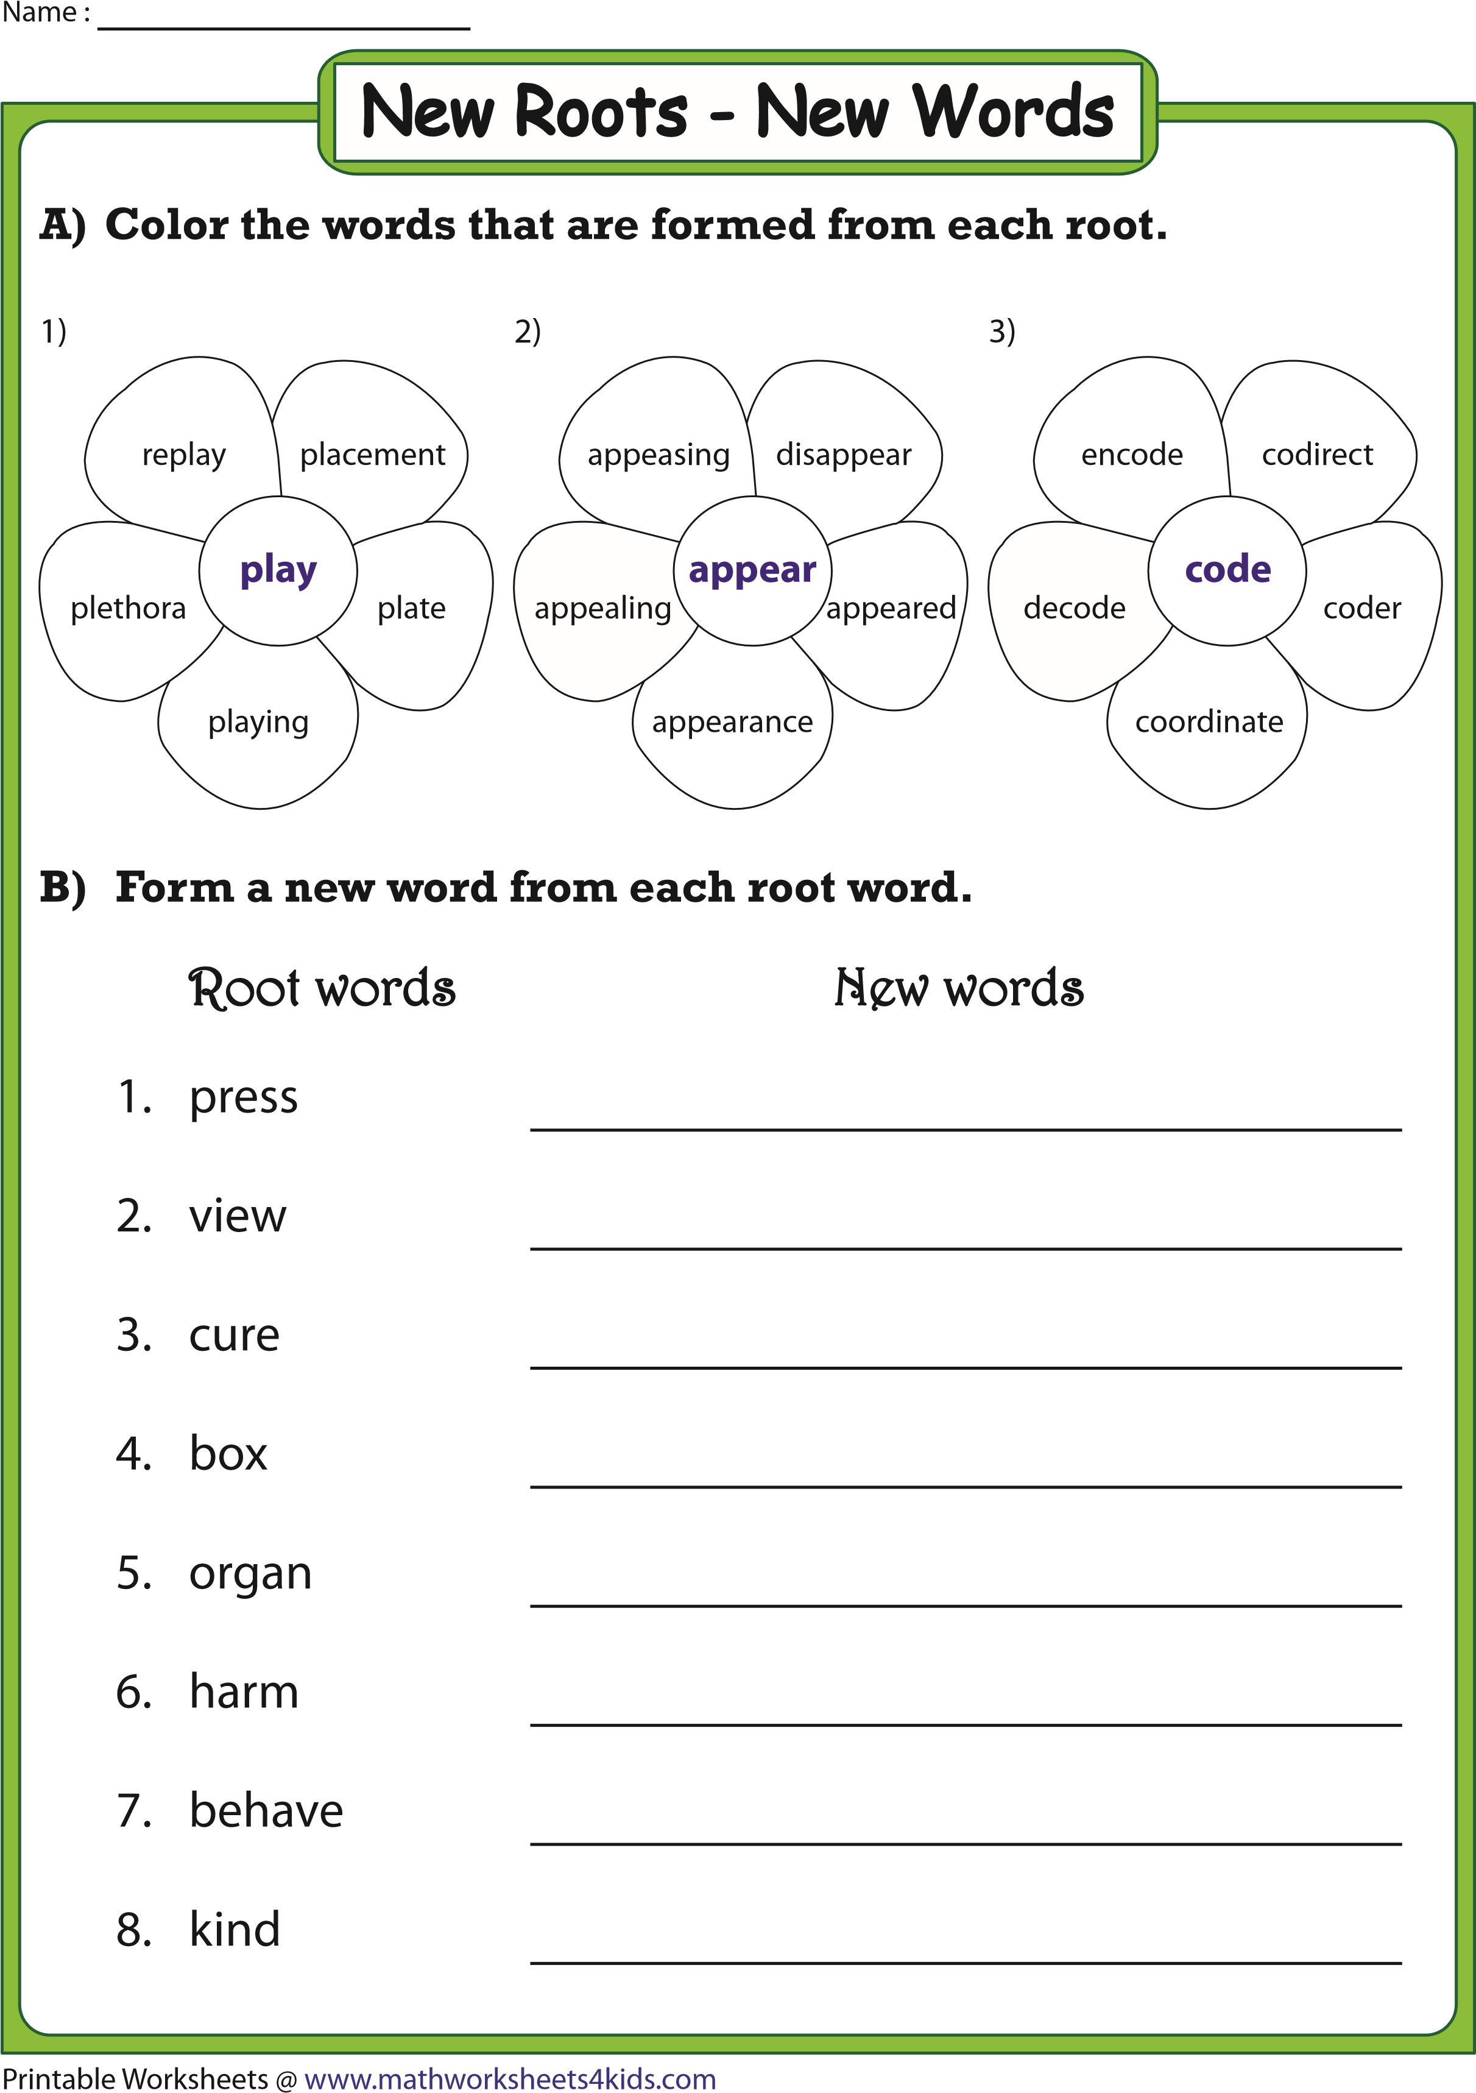

**B)Form a new word from each root word.**

**Answers may vary**

**(**

**)**

**Color the words that are formed from each root.**

**A)**

Root words

New words

1.

2.

3.

4.

5.

6.

7.

press

view

cure

box

organ

harm

behave

kind

8.

**compress**

**preview**

**curable**

**inbox**

**organism**

**harmful**

**misbehave**

**unkind**

1)

plate

**play**

replay

playing

plethora

placement

2)

**appear**

disappear

appealing

appearance

appeared

appeasing

3)

**code**

encode

decode

codirect

coder

coordinate

Printable Worksheets @

www.mathworksheets4kids.com

Name :

**Answer key**

New Roots - New Words