Similes
Complete each simile by gluing the correct picture card to it.
1)
as tall as a
2)
as wise as an
3)
as big as an
4)
as busy as a
5)
as meek as a
6)
as proud as a
7)
as lame as a
8)
as blind as a
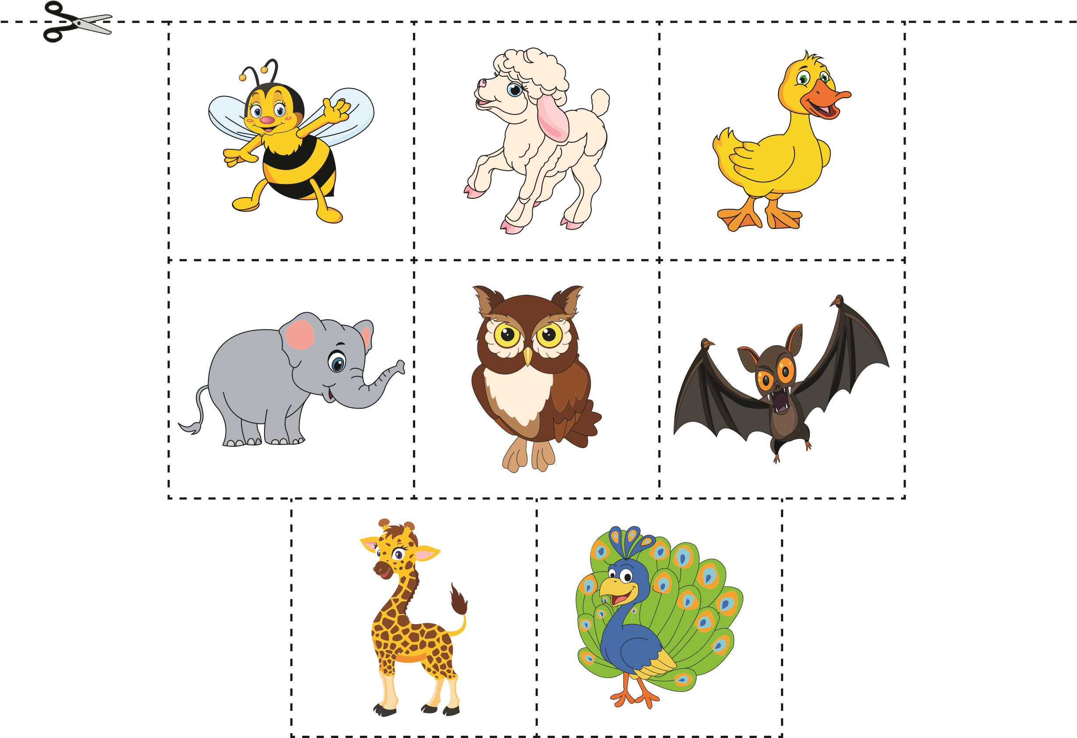
Similes
Answer key
Similes
Complete each simile by gluing the correct picture card to it.
