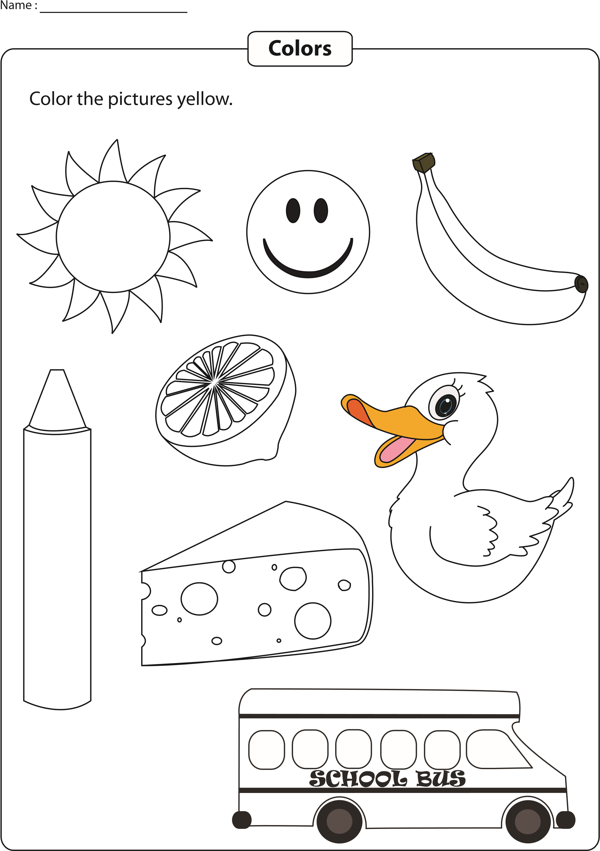
Printable Worksheets @ www.mathworksheets4kids.com
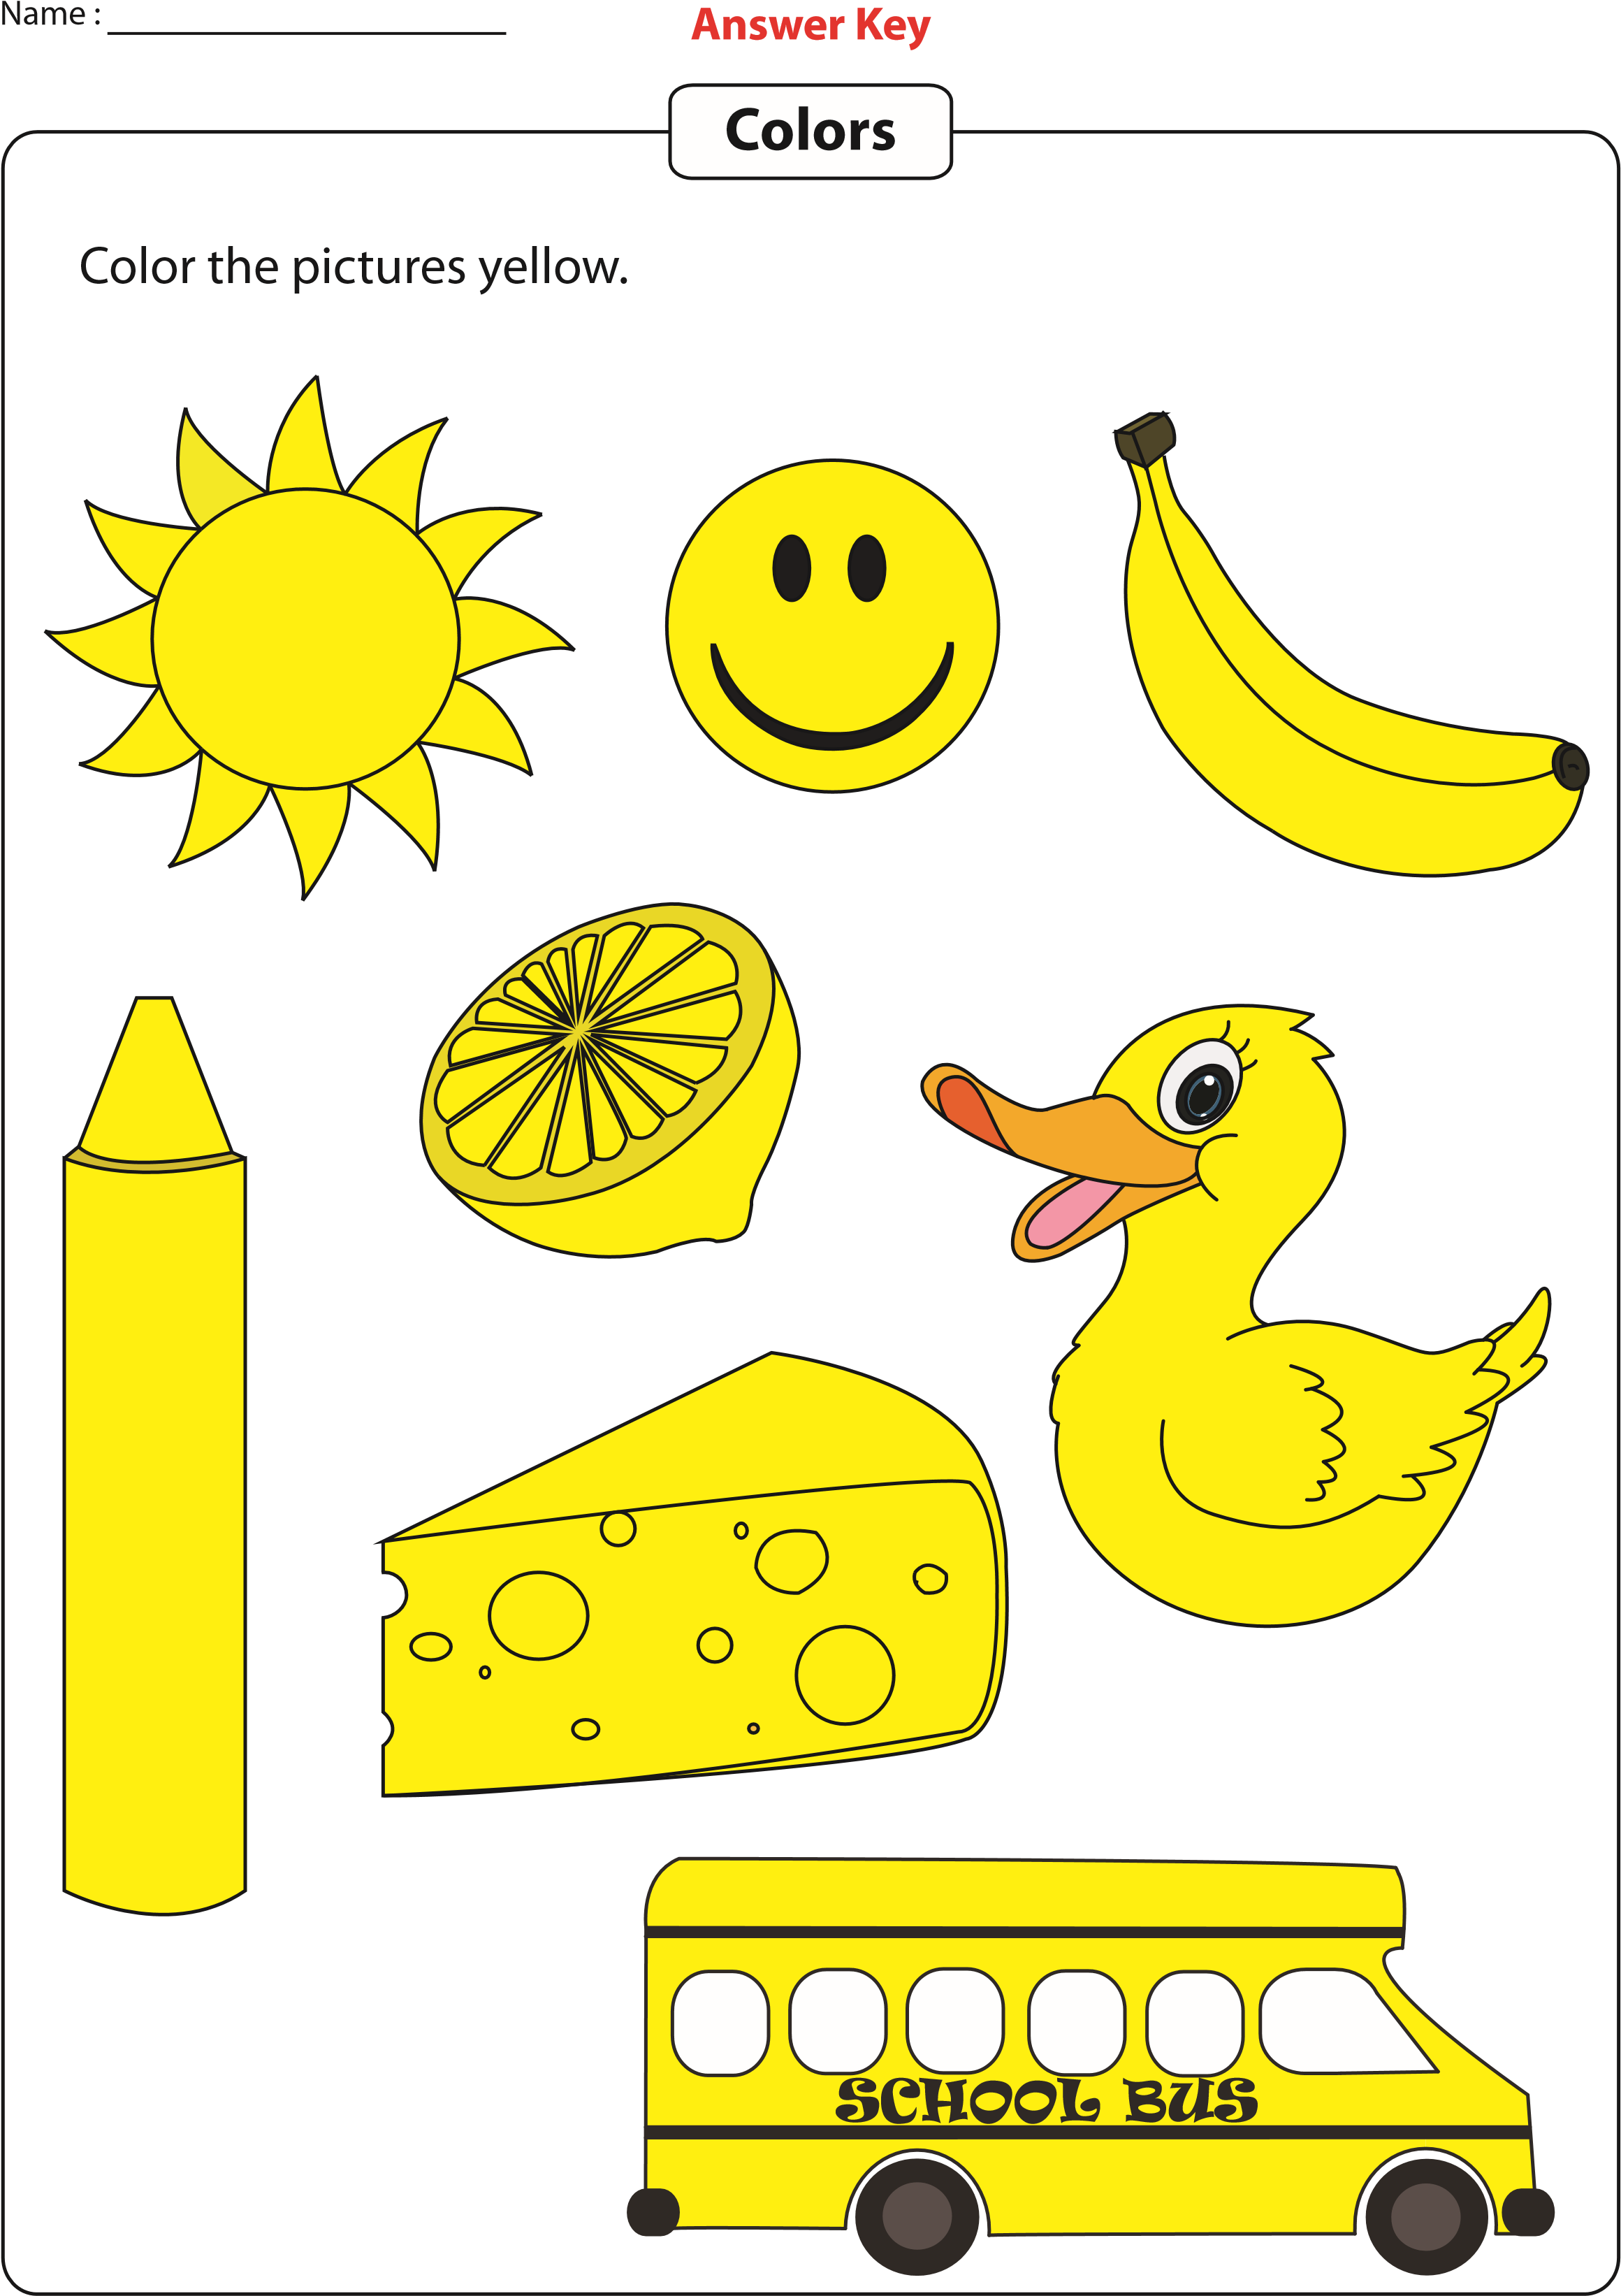
Printable Worksheets @ www.mathworksheets4kids.com

