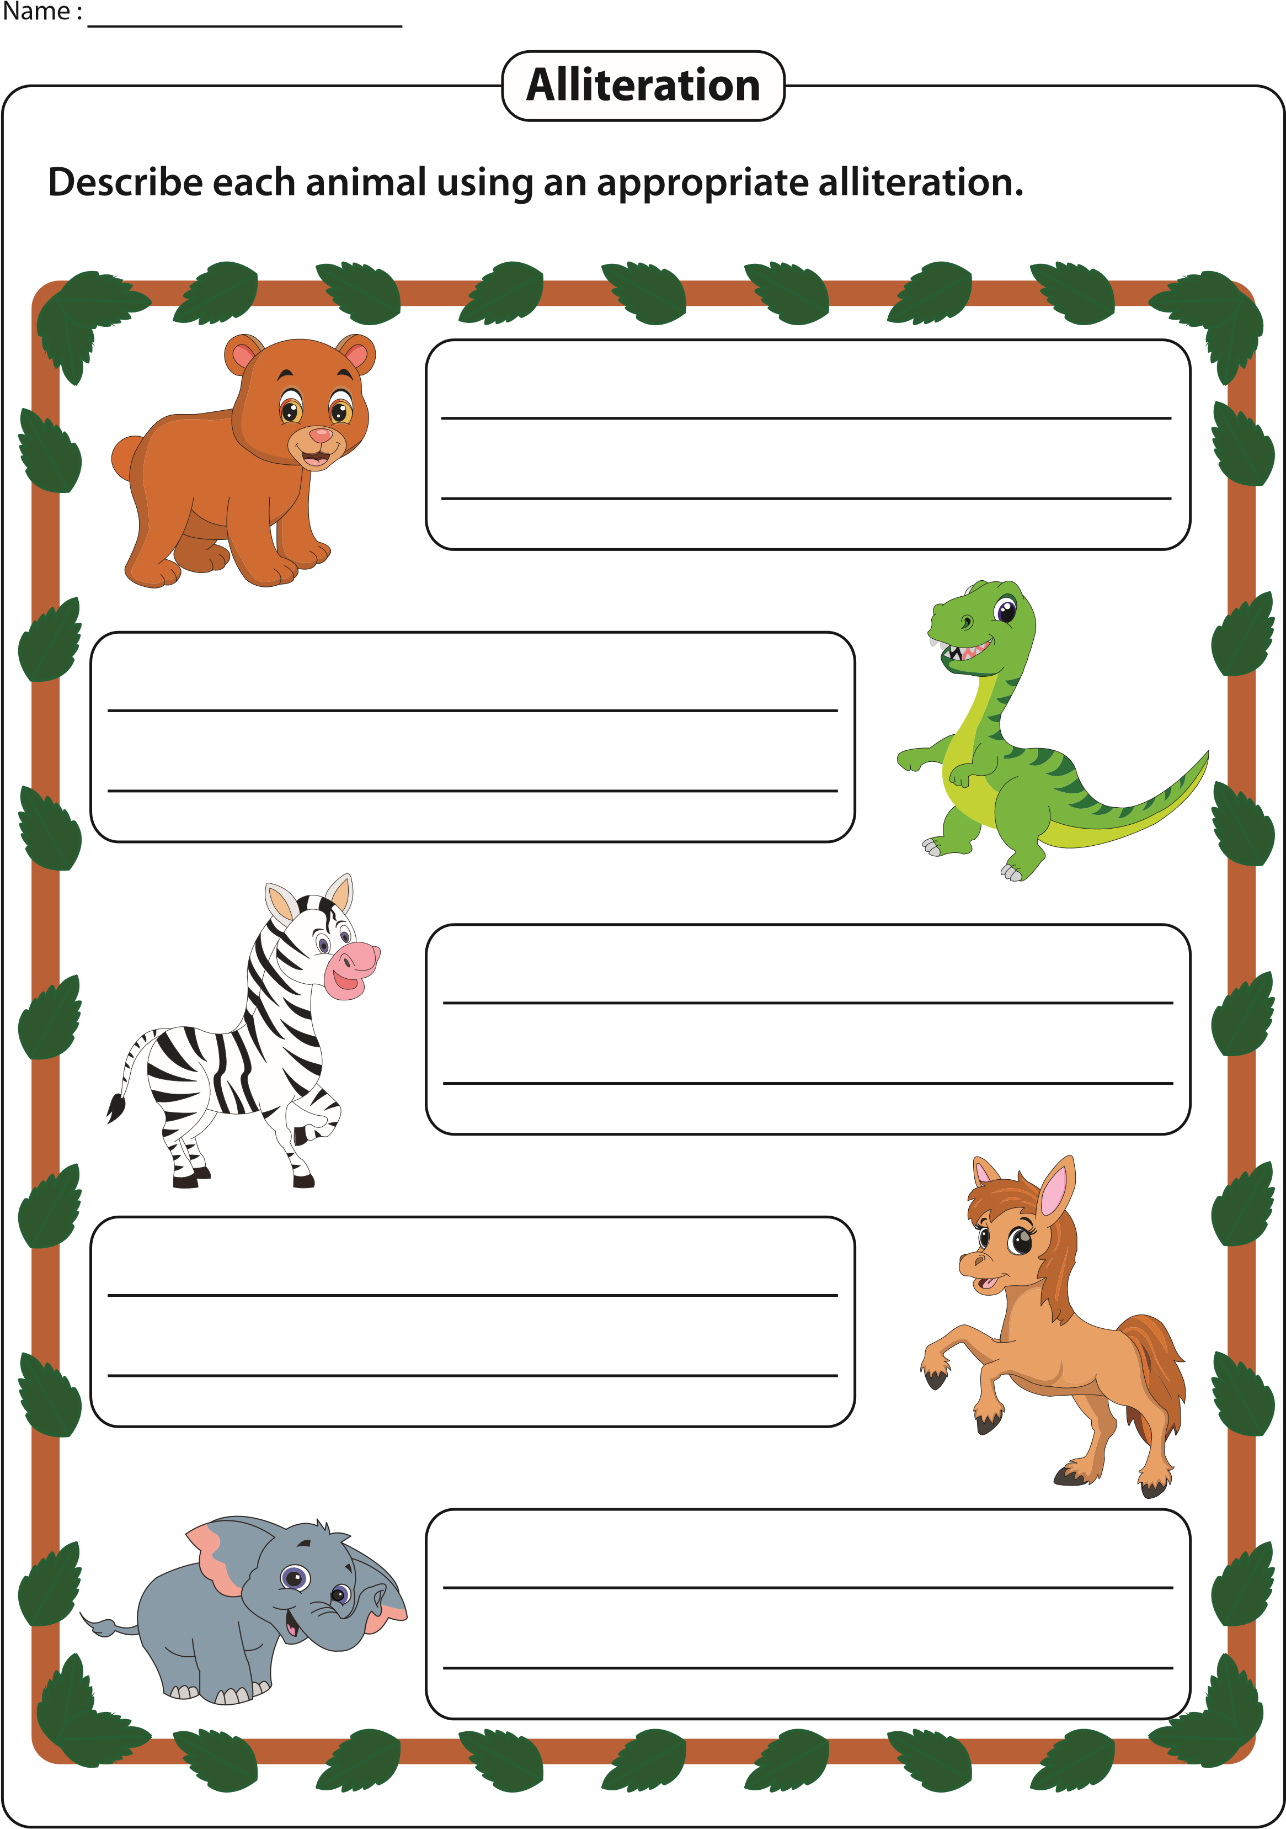
Printable Worksheets @ www.mathworksheets4kids.com

